MODERN PHILOSOPHY
Thinking in Letters

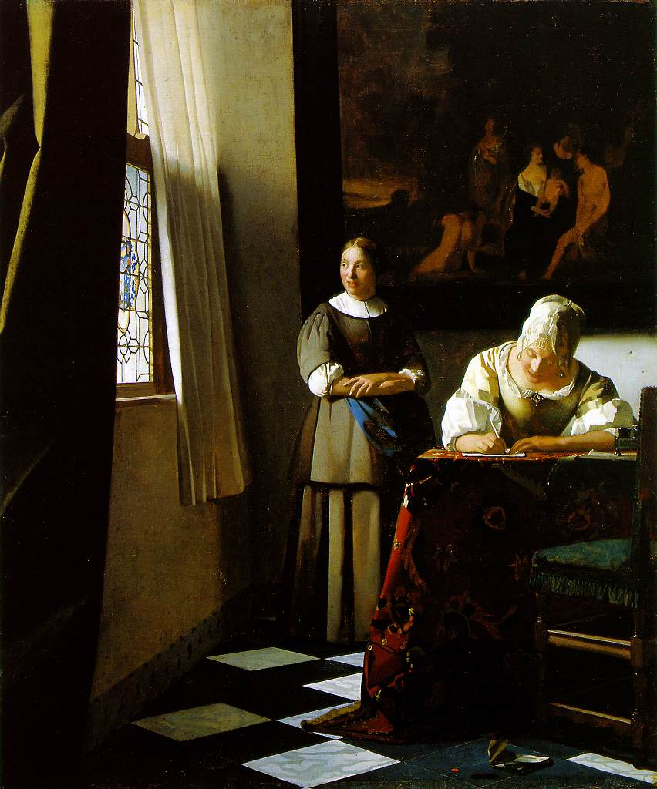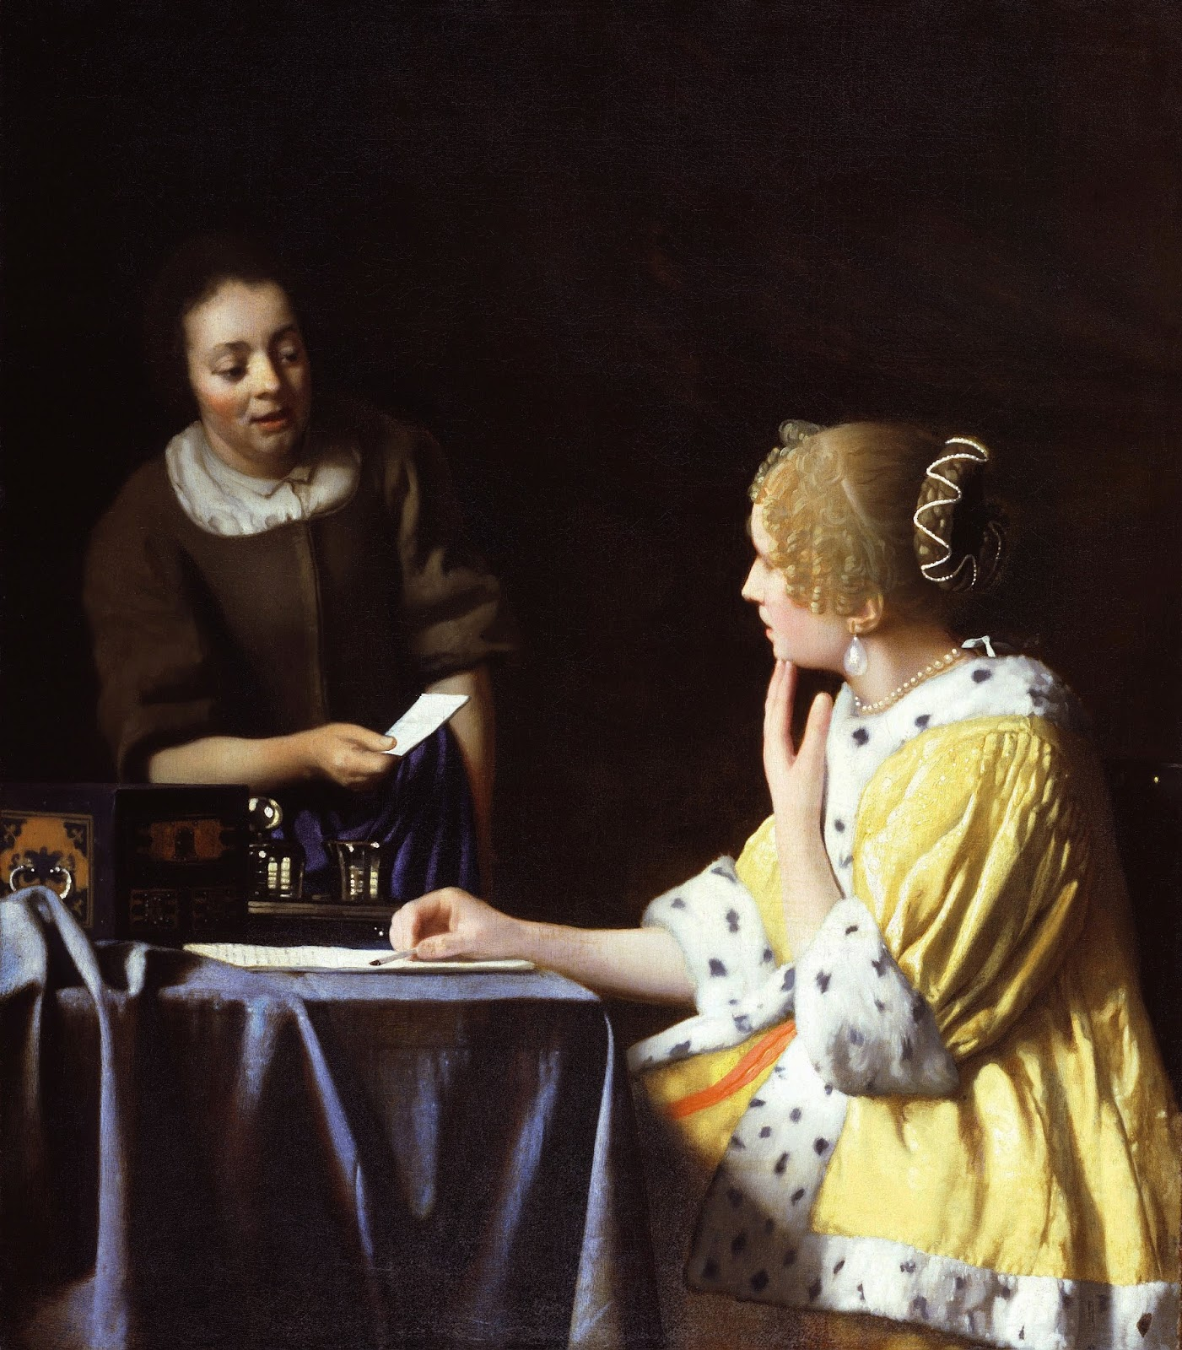
Vermeer, Lady Writing a Letter with Her Maid (1670-1) Vermeer, Lady with Her Maidservant Holding a Letter (1767-8)

Overview
In the seventeenth-century, a vast network of intellectual and literary communities emerged in Europe and North America. This community spread across political, religious, cultural, and gender divisions. The main reason for the emergence of such a diverse community was the increase in the popularity of letter writing. Until now, the philosophical significance has not been considered in much detail. This class will take up this task and consider the practice of letter writing as a form of philosophical discourse.

Let’s think about how most philosophy is done. Most academic classrooms assume that philosophy is expressed in one form: the book. A quick survey through the canon, however, reveals that there are various forms of philosophical writing. The most popular and lasting works by Aristotle, Augustine, John Locke, Hegel, Heidegger, etc. take the form of a grand treatise or a magnum opus. Despite the preponderance of treatises in philosophy, the book is only one form of “doing philosophy.” We can list several other forms. Poetry is one of the earliest forms of philosophical writing. From Parmenides’ On Nature to Lucretius’ The Nature of Things to Nietzsche’s “A Prelude in Rhyme” that begins his Gay Science, plenty of philosophy has been written in poetic verse. Dialogue or dramatic plays are also quite common. Plato’s dialogues are the most popular example, though everyone from Aristotle to Descartes wrote dialogic philosophy. There also manifestos, such as those of Marx and Engel. In the last few centuries, essays and journal articles became perhaps the most common forms of philosophical writing. The Information Age has provided a whole new set of forms, including philosophy blogs, tweets, videos, etc. Given all of these, it seems clear to me that there is not a single correct way to write philosophy. Despite the continuous practice of writing letters, from the ancient Athens to the twenty-first century, there has not yet been a sustained focus on letter writing as a philosophical mode of discourse. This class will thus ask us to consider the philosophical import of epistolary writing.

There will be four sections of letter writings. First, we will look at the letters sent between René Descartes and Princess Elisabeth of Bohemia. These letters will take us into an unusual conversation for the Modern Period. Unlike anything before or after, the Republic of Letters allowed women’s voice to enter into the philosophical conversation. While Descartes, often considered the “Father of Modern Philosophy,” exchanged letters with all of the luminaries of the early 17th-century, it was a young woman, Princess Elisabeth who offered the most important and devastating challenge to Cartesianism. Second, we will turn to Margaret Cavendish’s fake letters. In these, Cavendish engages in epistolary debate with Thomas Hobbes, Descartes, and other leading male voices in European thought, though without ever actually exchanging letters. The men would not deign to give her an audience, so she made them do so. Third, we then take up the unfinished correspondence between G.W.F. Leibniz (the last person to “know everything”) and Samuel Clarke, the ardent supporter of Sir Isaac Newton. Fourth and finally, we will turn to person who I take to be the most important figure of Modern Philosophy: Baruch Spinoza. After looking at a few of his more important letter exchanges, we will finish the course by taking up the central book in his breathtaking masterpiece: the Ethics.

