Center for the Advancement of Teaching & Learning (CATL) |  | 5-Year Plan  2016-2021

Mission

Founded in 2005, the Center for the Advancement of Teaching and Learning (CATL) serves as a catalyst for effective teaching and engaged learning at Elon University.

CATL faculty promote intentional, evidence-based, and inclusive teaching and learning practices, contribute to University-wide initiatives related to teaching and learning, and foster the scholarship of teaching and learning at Elon University.

To fulfill this mission, CATL partners with Elon faculty, staff and students to fulfill the following objectives:
- Foster innovative, evidence-based teaching and learning practices and critical reflection through programs & services designed for faculty working in a range of teaching and learning contexts,
- Develop new programming and services responsive to the needs of individual faculty as well as to the broader community, remaining attentive to the Center’s mission and capacity,

Create, share, and curate resources to advance teaching and learning,
- Strengthen and deepen our support for faculty as they develop integrated, purposeful careers as teacher-scholar-mentors, in collaboration with university partners,
- Contribute to national and international conversations about high-impact pedagogy, inclusive classrooms & pedagogy, educational development, and faculty mentoring, and
- Conduct ongoing assessment of the Center’s work and impact.

CATL faculty and staff work according to shared values. All programs and services are…
- confidential, voluntary, and formative, not evaluative,
- grounded in evidence drawn from research and effective practice,
- responsive to the specific goals and questions of the faculty, staff or students with whom we work and to ongoing assessment of Elon’s local context,
- inherently collaborative and responsive to the broad needs, dynamic contexts, and evolving research that frame and surround teaching and learning locally, nationally, and globally.

Strategic Directions for 2016-2021

During the next five years, CATL will enhance the capacity of Elon’s faculty as Teacher-Scholars so they can advance Elon’s mission and further enhance the university’s reputation as a national and international leader in engaged learning. We will focus on the following strategic areas:

- Advancing High-Impact Pedagogy
We will continue to promote meaningful, evidence-based, and high-impact learning experiences as our first priority, supporting faculty and programs in the practice and scholarship of effective and innovative teaching and learning.

- Fostering Inclusive Classrooms and Pedagogies
We will continue to develop programs that support teaching faculty and staff as they engage all learners while responding to the complex demands and opportunities found in diverse educational environments.

- Supporting Faculty Growth and Development
In collaboration with other university partners, we will develop and deepen programs that facilitate faculty growth, professional goal-setting, and habits of critical reflection to support the Elon Teacher-Scholar model, complement mentoring support at the department and school level, and respond to distinct challenges and opportunities across the faculty career.

- Enhancing the Culture of Teaching and Learning
We will strengthen our efforts to enhance the “generative culture” of teaching and learning at Elon through the center’s role as a collaborative and community-building resource for Elon’s growing academic community.

Over the next five years, Elon will continue to lead the nation in high-impact practices and engaged learning. The Center for the Advancement of Teaching and Learning will continue a focus on mentoring and professional development support for teaching and learning, to support Teacher-Scholars and the students they teach, collaborate with, advise and mentor. The CATL Strategic Plan, 2016-2021 is intentionally broad in order to provide some flexibility for the Center faculty and staff to remain responsive to faculty and institutional needs. The plan includes some work already underway in the Center, while also leaving room for emerging initiatives as institutional strategic planning and planning for other external accrediting bodies move forward within this time period.

Goals for 2016-2021

1. Advancing High-Impact Pedagogy

“[T]he knowledge needed for teaching is often deeply contextual and tied closely to the details of classroom practice.”
Huber & Hutchings, The Advancement of Learning:
Building the Teaching Commons, 2005, p. 122.

We will continue to promote meaningful, evidence-based, and high-impact learning experiences as our first priority, supporting faculty and programs in the practice and scholarship of effective and innovative teaching and learning, as we:

- Continue to select and mentor CATL Associate Directors in relation to CATL’s mission and plan for the ongoing work of the center and in the special projects developed during their terms.
- Develop course and assignment design programming, faculty learning communities, and web resources for targeted audiences, in collaboration with other programs and faculty fellows when appropriate, and in keeping with evidence-based faculty development practices (Appendix A).
- Develop programming for targeted departments, programs, or faculty cohorts teaching with similar methods or in similar contexts, on an annual or biannual cycle, in response to themes elicited through outreach (see “Enhancing the Culture of Teaching and Learning” below), needs assessment, or by request.
- Evaluate existing CATL programs and processes on a five-year cycle, and use that data to refine and deepen existing programs and processes, to develop new ones that better meet emerging needs for teaching and learning, and to help showcase innovative and effective teaching at Elon.
- Develop a cycle for small-scale studies of teaching and learning topics that might better inform teaching at Elon, or that emerge as common themes in work with faculty or campus partners.
- Support, showcase, and assess high-quality scholarship of teaching and learning projects on campus, through workshops, programming, and collaborations with campus colleagues engaged in similar work.
- Develop a communication plan and annual cycle for creating and sharing online resources about high-impact and evidence-based practices on social media and on a newly designed CATL website.

2. Fostering Inclusive Classrooms and Pedagogies

“Learning doesn’t happen in a vacuum but in a course and classroom context where intellectual pursuits interface with socioemotional issues. […] as instructors, we have a great deal of control over the climate we shape, and can leverage climate in the service of learning once we understand how and why it influences student learning.”
Ambrose et al., How Learning Works, 2010, p. 180

We will continue to develop programs that support teaching faculty and staff as they engage all learners while responding to the complex demands and opportunities found in diverse educational environments, as we:

- Evaluate, redesign and rename the Diversity Infusion Program, considering whether this format continues to best meet the purpose of the program.
- Evaluate, expand, and deepen online resources on the Inclusive Classrooms website, including moving it to the new CMS.
- Collaborate on university-level initiatives related to diversity and inclusion in ways that align with CATL’s mission.
- Create and share resources related to diversity and inclusion with department chairs, deans, and/or the Associate Provost charged with chair leadership development. These materials might include such items as a summary of research findings related to student evaluations and profession identity categories, or resources focused on areas of interest or concern to a department, such as materials on “teaching students on the spectrum” or other emerging topics.

3. Supporting Faculty Growth and Development

“[W]e position ‘faculty growth’ in professors’ ‘professional lives’ […] as (1) ongoing and in a constant state of becoming as opposed to being fixed, (2) a process that is facilitated by external environments but that also much be viewed in terms of what individuals themselves want and need as developing persons, and (3) set in a specific sociocultural and personal context relative to faculty members’ identities, roles, and works.”
O’Meara et al., Faculty Careers and Work Lives:
A Professional Growth Perspective, 2008, p. 25

In collaboration with other university partners, we will develop and deepen programs that facilitate faculty growth, professional goal-setting, and habits of critical reflection to support the Elon Teacher-Scholar model, complement mentoring support at the department and school level, and respond to distinct challenges and opportunities across the faculty career, as we:

- Expand and evaluate support for faculty at distinct career stages or roles in collaboration with deans, department chairs, and other campus partners, including the new faculty orientation and midcareer development program.
- Develop and offer a series of workshops focused on communicating about one’s teaching and evidence of teaching effectiveness, and explore possible collaborations with the Center for Writing Excellence and Academic Council and other appropriate partners on related topics.
- Develop more specific suggested guidelines and resources for mutual mentoring groups focused on critical reflection and professional goal-setting.
- Evaluate and expand web resources available for faculty growth and development across career stages, including revamping the existing new faculty website and adding materials relevant to other career stages.
- Establish formal structures and ongoing activities to support part-time faculty, in collaboration with other campus partners.
- Conduct a needs assessment of late career faculty, related to this strategic direction, and explore possible programming and resource development, in collaboration with other campus partners.

4. Enhancing the Culture of Teaching and Learning

Research by Condon et all, (Faculty Development and Student Learning, 2016) suggests that a “generative culture of teaching and learning…”
- “provides the crucial environment for ongoing faculty learning that benefits students, faculty, and the institution as a whole” (p. 6),
- “multiplies the impact of formal faculty development, enhances self-motivated, individual faculty learning, and supports faculty experimentation in their courses” (122), and
- “creates an environment that promotes faculty learning so that faculty can encourage improvements in students’ learning.” (p. 122)

We will strengthen our efforts to enhance the “generative culture of teaching and learning” at Elon through the center’s role as a collaborative and community-building resource for Elon’s growing academic community, as we:

- Develop and share resources for department chairs on topics related to supporting faculty colleagues in their teaching and professional development (e.g., peer observation process, research on student evaluations, and related topics).
- Explore, and if feasible, create a new grant for departments focused on enhancing some aspect of teaching and learning at a departmental level, in collaboration with other campus partners as appropriate.
- Create a two-year cycle for undertaking and assessing in-depth and strategic partnerships with targeted centers, units, or programs on campus supporting high-impact practices (including ELRs) or other forms of specialized faculty development on campus.
- Continue, deepen, and assess on-going collaborations with other centers, units, and programs on campus supporting specialized faculty development around high-impact practices and teaching and learning technologies.
- Foster productive and generative conversations around teaching and learning at Elon, through targeted outreach to deans, department chairs and faculty.
- Develop programming and web resources to respond to needs and interests identified through programs and outreach (See “Advancing High-Impact Pedagogies” above)
- Continue to raise the profile of Elon as a model for engaged learning and innovative, evidence-based teaching, in collaboration with other university partners.
- Participate actively in national and international conversations about teaching, learning, and educational development.

Appendix A: “Using Evidence-Based Faculty Development to Promote Evidence-Based Teaching.”
Source: Sorcenelli, M.D. Austin, A.E, Beach, A. “Using Evidence-Based Faculty Development to Promote Evidence-Based Teaching.” POD Network Annual Conference, November 2016.
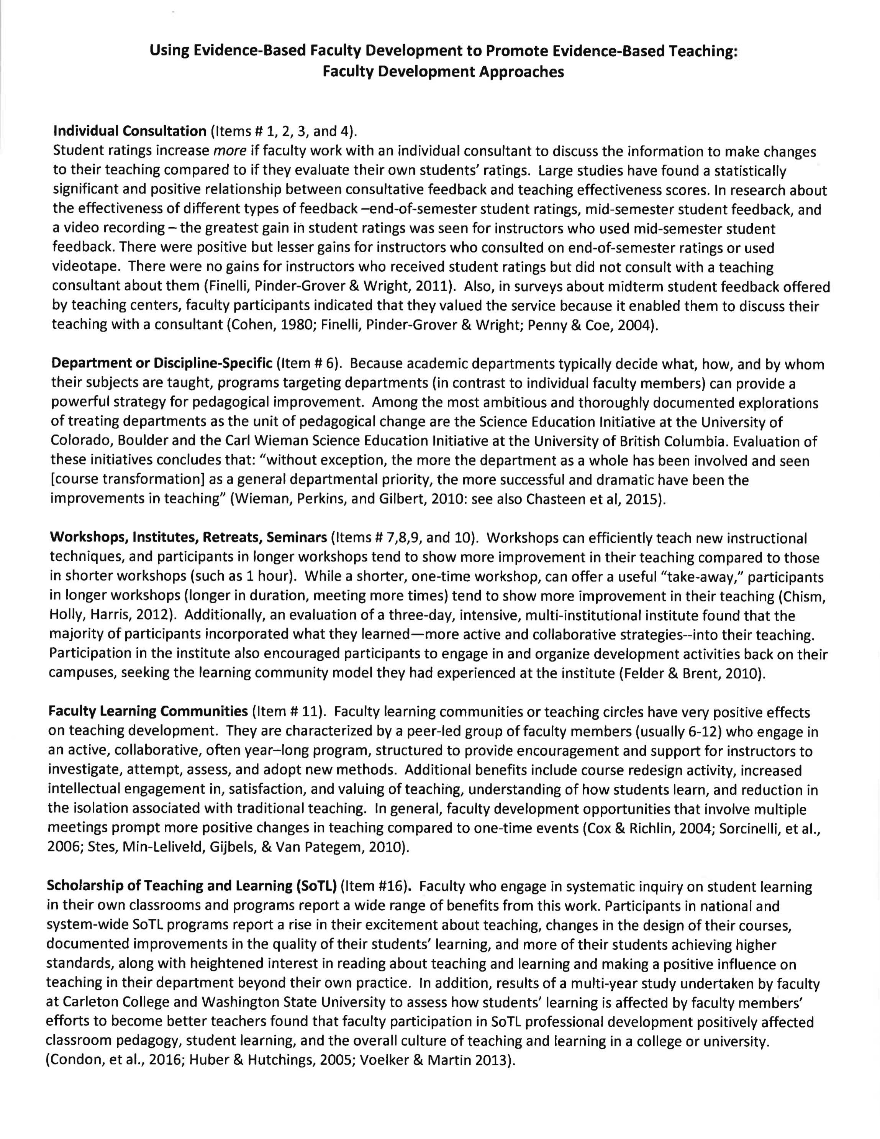
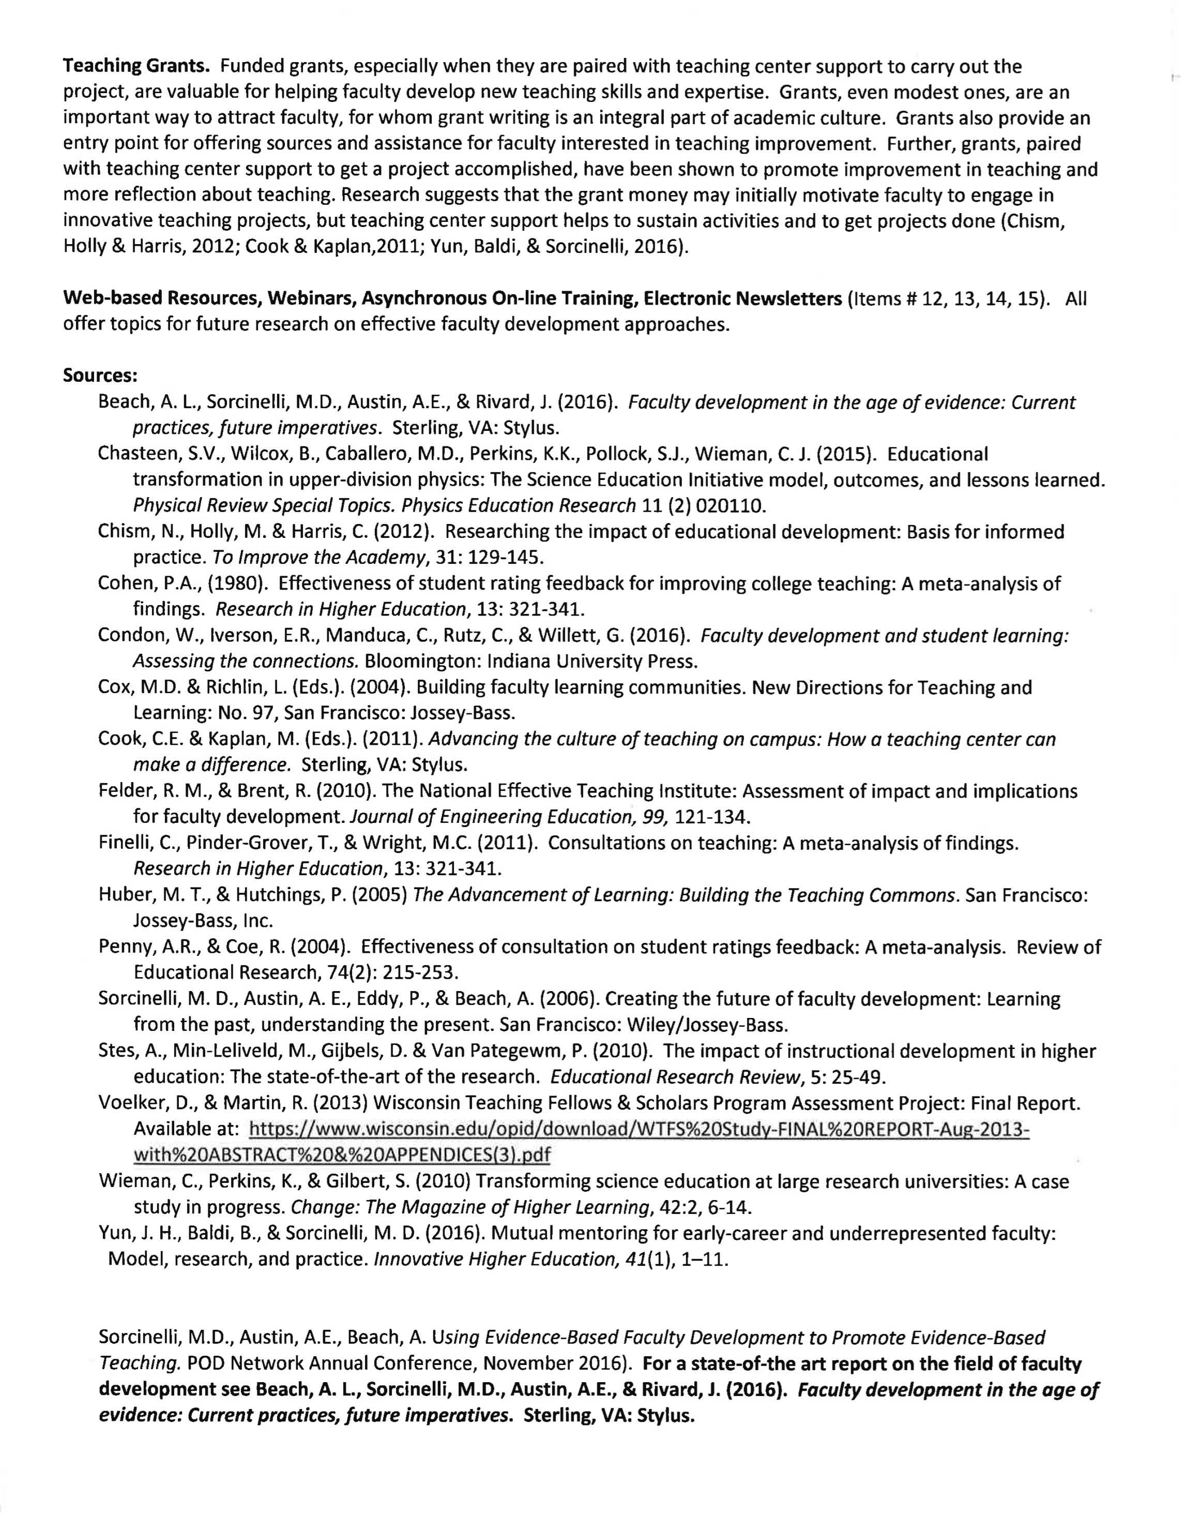

See Appendix A: Evidence-Based Faculty Development for Evidence-Based Teaching

