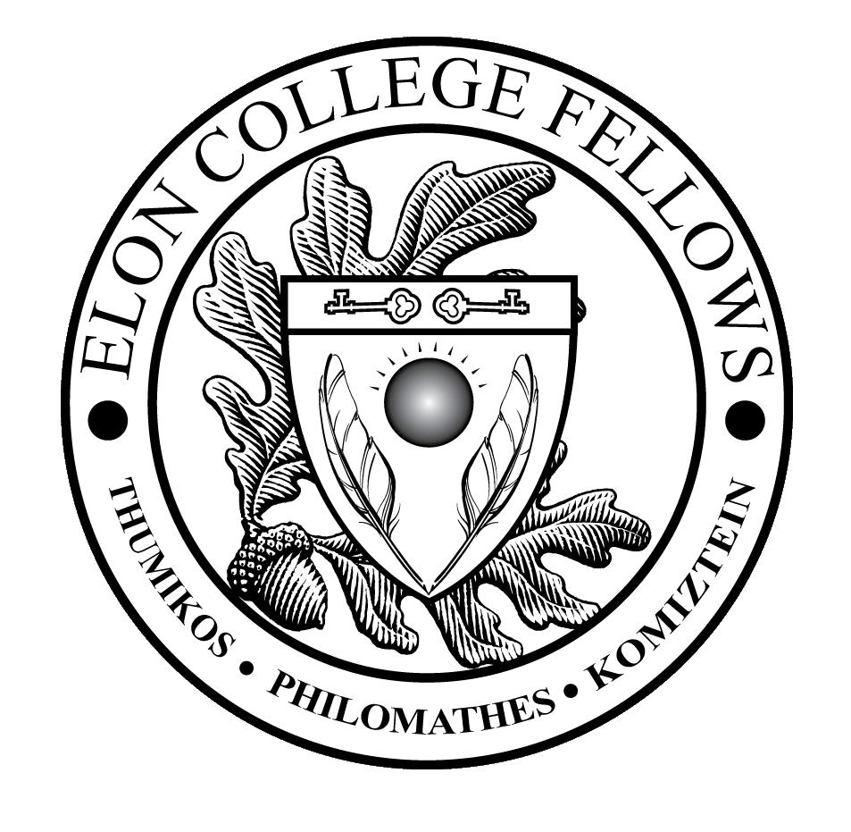

Elon College Fellows (ECF LLC) Syllabus
2017-18 academic year

Faculty Advisors: David Vandermast, Associate Professor of Biology (dvandermast@elon.edu)
Kirby Wahl, Professor of Performing Arts, and Associate Dean of Elon College, the College of Arts and Sciences (kwahl@elon.edu)

Offices: Vandermast: 124-B McMichael Science Building 336-278-6171
Wahl: 104A Lindner Hall, 336-278-5684

Historic Neighborhood staff:
Faculty Director: Max Negin, Assistant Professor of Communications (mnegin@elon.edu)
Community Director: Frank Hartfield (fhartfield@elon.edu)
Faculty Member in Residence: TBA
Resident Assistant: Aileen Bell (abell18@elon.edu) Student Ambassador: Jacob Hayward (jhayward@elon.edu)
Welcome to the ECF LLC!
Welcome to the Elon College Fellows LLC! This living-learning community brings together Elon College Fellows to share intellectual and social pursuits in Elon’s Historic Neighborhood. You were carefully selected to be part of this LLC, so please treat it as an honor and as an opportunity to learn about Elon University and the rest of the world through your interactions and engagement with fellow residents, cultural events, speakers, concerts, and other activities, both within the Historic Neighborhood and beyond.
This unique community fosters cross-cultural appreciation, intercultural competency, respect for diversity, curiosity and awareness about international trends and issues. It is a multicultural environment that values difference and shares Elon University’s priority of internationalizing the campus through activities such as study abroad, international exchanges, and language learning.
Goals
- To bring together Elon College Fellows with common challenges to share solutions in a collaborative environment

- To connect students to a faculty director, to faculty advisors, and to a resident assistant (RA) who also share these interests and who will work to build relationships with them around areas of mutual concern

- To create a community that serves as a social network and as an intellectual resource, a community that will help students succeed inside and outside of the classroom

- To take advantage of the wealth of activities happening across campus, such as lectures, concerts, performances, speakers, and more, and to connect those activities with international themes and trends, encouraging discussions and reflections

- To learn from differences and diversity among the residents

- To integrate classroom themes with residential conversations and planned programming in an intentional, learning-centered community

Activities
You will find a timeline below of some of a few activities we will participate in this year. These activities are intended to build community; some will help you to understand important issues and trends, and some are just plain fun. Take advantage of them. In the timeline, you will see that these activities are required for the ECF LLC, which means that your attendance is expected. As Elon President Leo Lambert has said many times at Convocation, “If you are invited to a great banquet, don’t make yourself a bologna sandwich.” Seize the day: enjoy, explore, learn, share, interact, venture… You will not regret it.
You will have the support of your Faculty Advisors (David Vandermast and Kirby Wahl), and your neighborhood staff: Faculty Director (Max Negin), Community Director (Frank Hartfield) and Resident Assistant (Aileen Bell), who will work with you to make the best out of this experience. We are here for you, and will be attending selected activities with you, to guide discussions and reflections and to answer questions along the way.
Not only will you get to know your fellow ECF LLC students, you will be invited to participate with them in some University-wide LLC activities, including:
- Mural competition
- Video challenge
- Service opportunities

TIMELINE OF ACTIVITIES FOR FALL 2017

September 2016 – We want to have lunch with each of you in small groups (2-3 people). This is a casual meal intended for us to get to know one-another. We’ll have some Thursday and Friday lunch times available and will ask you to sign up for one of them at the beginning of the semester.

September 5 – Fall ECF Picnic (5:00 – 8:00 Elon Community Church)

September 12 – Colloquium #1 (5:30 – 7:30 Oaks 212)

September 26 – Attend Rich Benjamin’s talk: “Searching for Whitopia: The Improbably Journey to the
Heart of White America,” in Whitley Auditorium, at 7:30 p.m.

October 5-11, Date TBA (to include a post-performance chat with the director) – Attend performance of
American la Ronde, written by Steven Dietz, directed by Kevin Otos. Produced by the
Department of Performing Arts, in Roberts Studio Theatre, Scott Studios at Arts West, at 7:30 p.m.

October 3 – Colloquium #2 (5:30 – 7:30 Oaks 212)

November 7 – Colloquium #3 (6:00 – 7:30 Oaks 212)

Please feel free to give us ideas about other things that you would like to do as a group.

Shared activities for the Spring term will be discussed later.

