International Living Learning Community (ILLC) Syllabus
Fall 2017/Spring 2018
Our Residence: Global Neighborhood, Building D, second floor (Zambezi)

Faculty advisor in residence: Glenn Scott, associate professor of Communications.
Residence: Faculty Apartment (#100) in Global Building A
Campus box: 2850 Campus Box, Elon, NC 27244
Office: Schar Communications, 214-E.
Global office hour: Wednesdays from 7:30 – 8:30 p.m. near Argo Tea.
Email: gscott3@elon.edu
Office phone: 336-278-5791
Cell phone: 336-269-8920

Global Neighborhood: Kaila Price, community dir. (kprice12@elon.edu) / 336-278-7339; Jennifer Eidum Zinchuk, faculty director (jzinchuk@elon.edu).
Resident Assistant: Annaliese Jaffe. Email: ajaffe@elon.edu
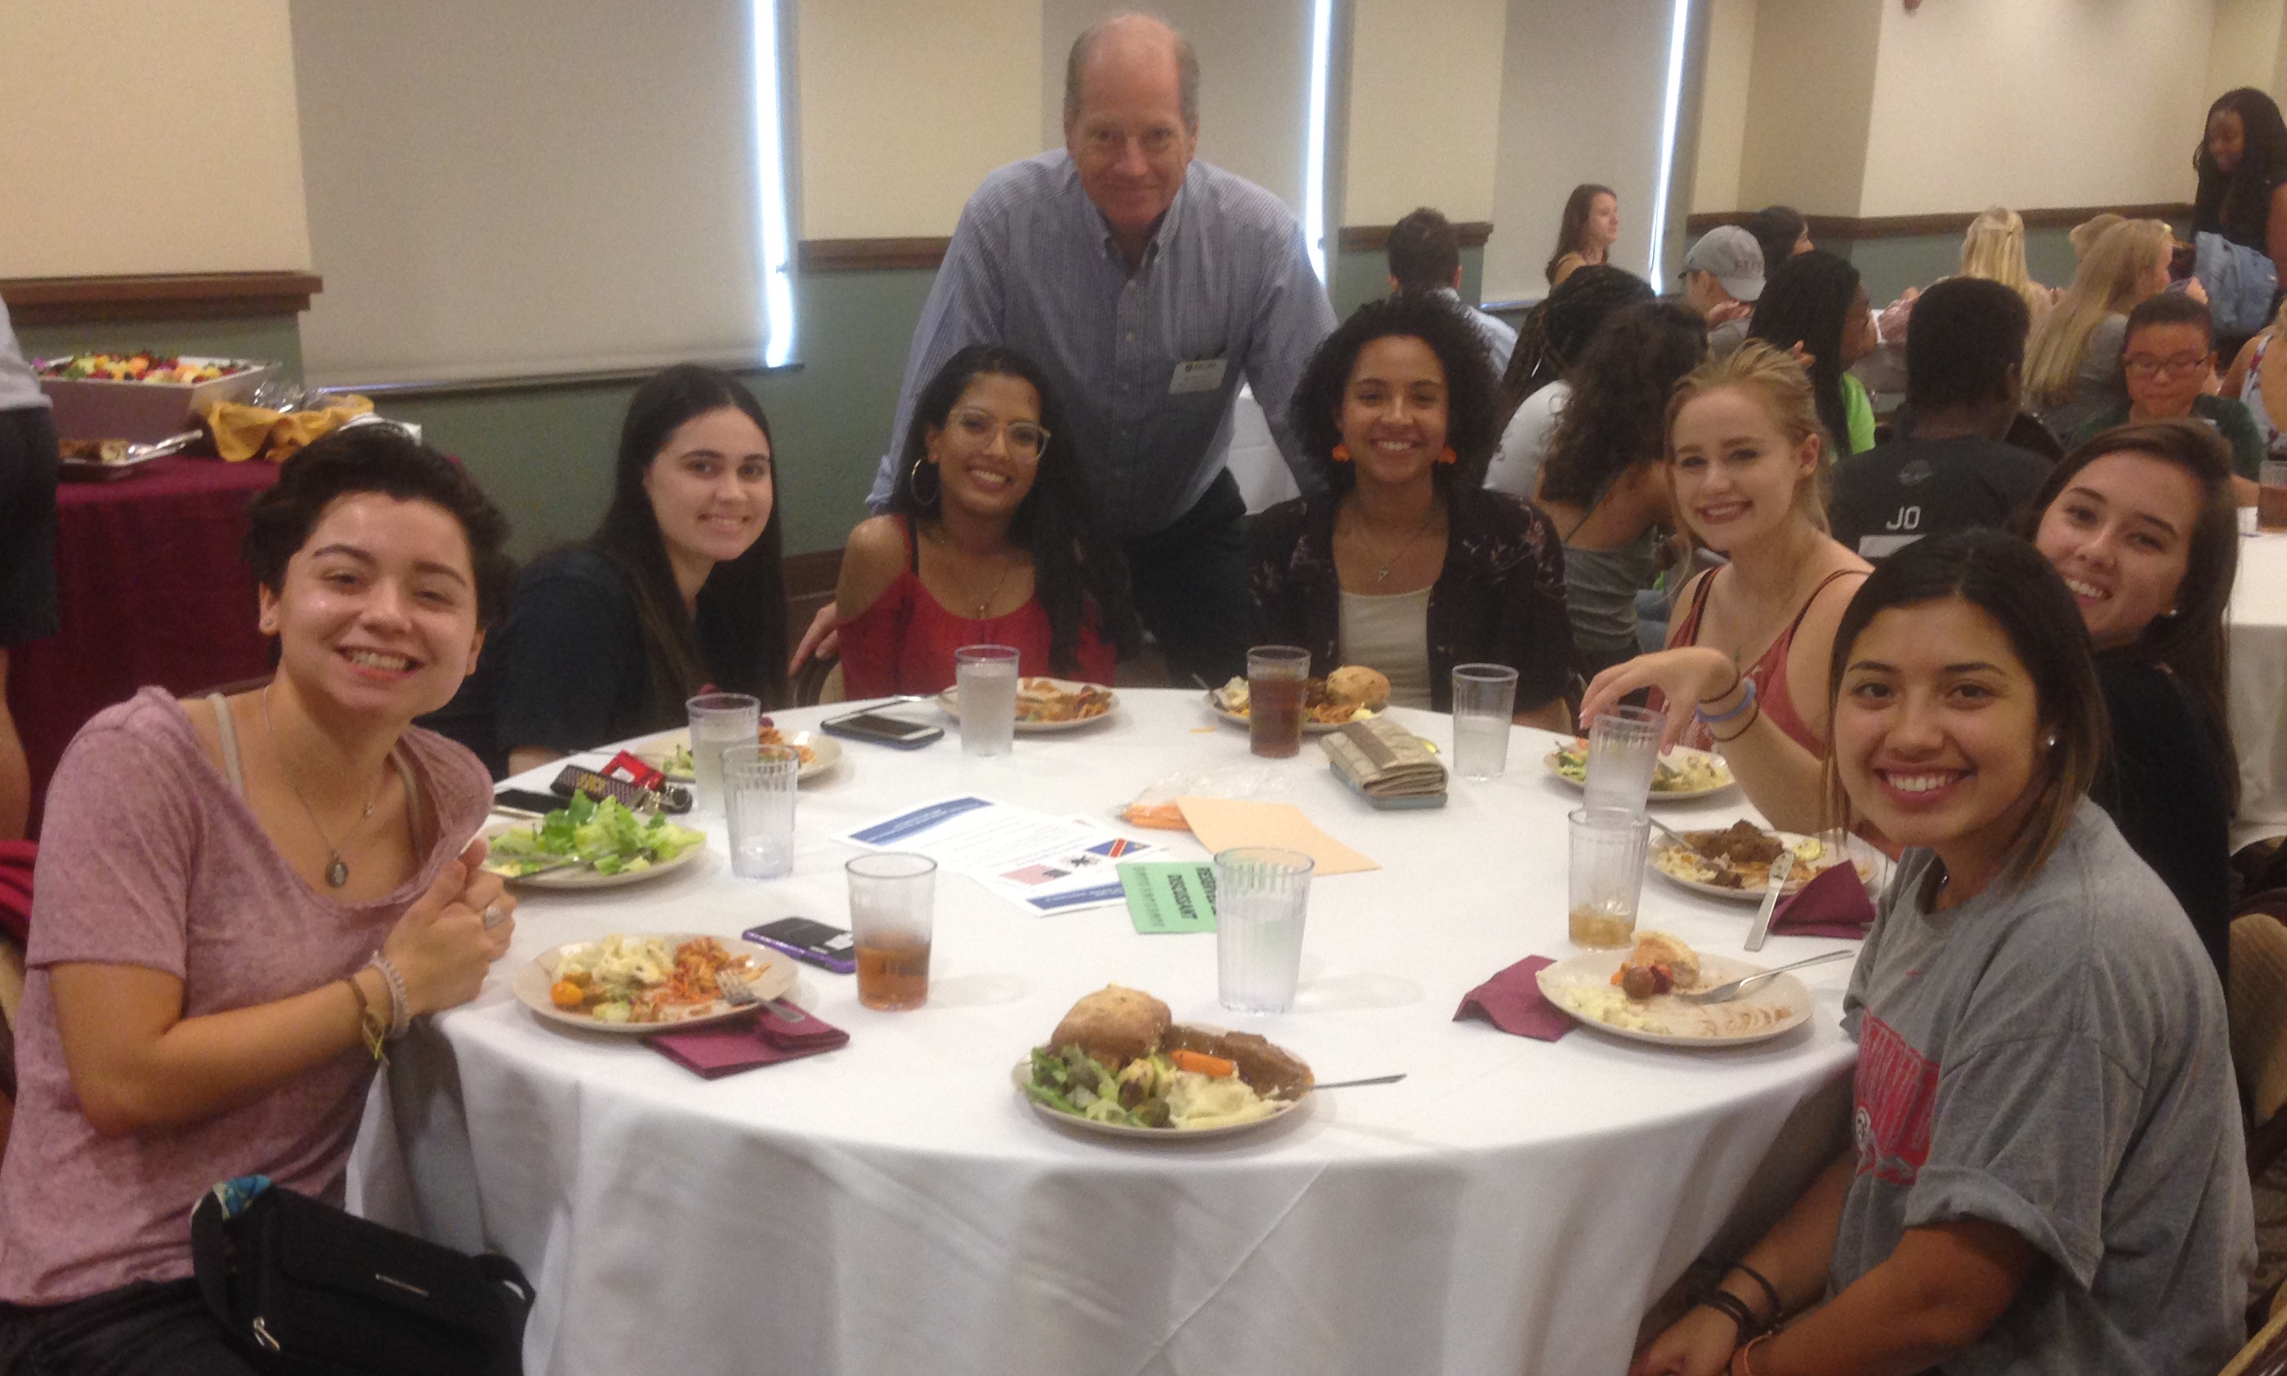
Welcome to the ILLC!
Welcome to the International Living and Learning Community! This intentional community in the Global Neighborhood brings together students with international backgrounds and experiences along with U.S. students who are interested in exploring cultures, issues, and opportunities around the world. We occupy the entire second floor of Global D and enjoy the warmth of shared community space in our lounge, kitchen and study areas. You were carefully selected to be part of the ILLC, so please accept your placement with us as an honor. Being a member of this LLC gives you opportunities to learn about the rest of the world (and yourselves) through interactions with your fellow residents, cultural events, speakers, concerts, trips, and other activities, within the Global Neighborhood and beyond.
This unique community fosters cross-cultural appreciation, intercultural competency, respect for diversity, curiosity, and awareness about international trends and issues. It is a multicultural environment that values difference and shares Elon University’s priority of internationalizing the campus through activities such as study abroad, international exchanges, and language learning.
Your Faculty Advisor
This is my second year with a wonderful group of scholars, and I’m eager to help shape your development intellectually, socially and in every other way. I’m particularly interested in working with this multi-cultural group because of my own interests as a former journalist who enjoyed dealing with people in and from many parts of the world. I spent three years working in Japan and later moved to the University of Hawaii to carry out studies of the Asia-Pacific region on a graduate fellowship. My doctorate is in mass communication, with an emphasis in international communications. I teach a course by that name at Elon. My wife Misako is from Japan, and our son Kevin (now a first-year student at Elon) is a dual citizen and a friend to many internationally oriented students on campus.
Our Objectives
- To bring together students interested in international experiences, issues, and interactions.

- To connect these students with a faculty director, a faculty adviser (in residence), and a resident assistant (RA) who also share your interests and who will work to build relationships around areas of mutual concern.

- To create a community that serves as a social network and as an intellectual resource, a community that will help students succeed in and outside the classroom.

- To take advantage of the wealth of activities happening across campus, such as lectures, concerts, performances, speakers, and more, and to connect those activities with international themes and trends, encouraging discussions and reflections.

- To learn from the cultural differences and diversity among the residents.

- To integrate classroom themes with residential conversations and planned programming in an intentional, learning-centered community.

- To continuously improve our community by monitoring activities and gaining your feedback. We want to support your social, intellectual, and emotional growth.

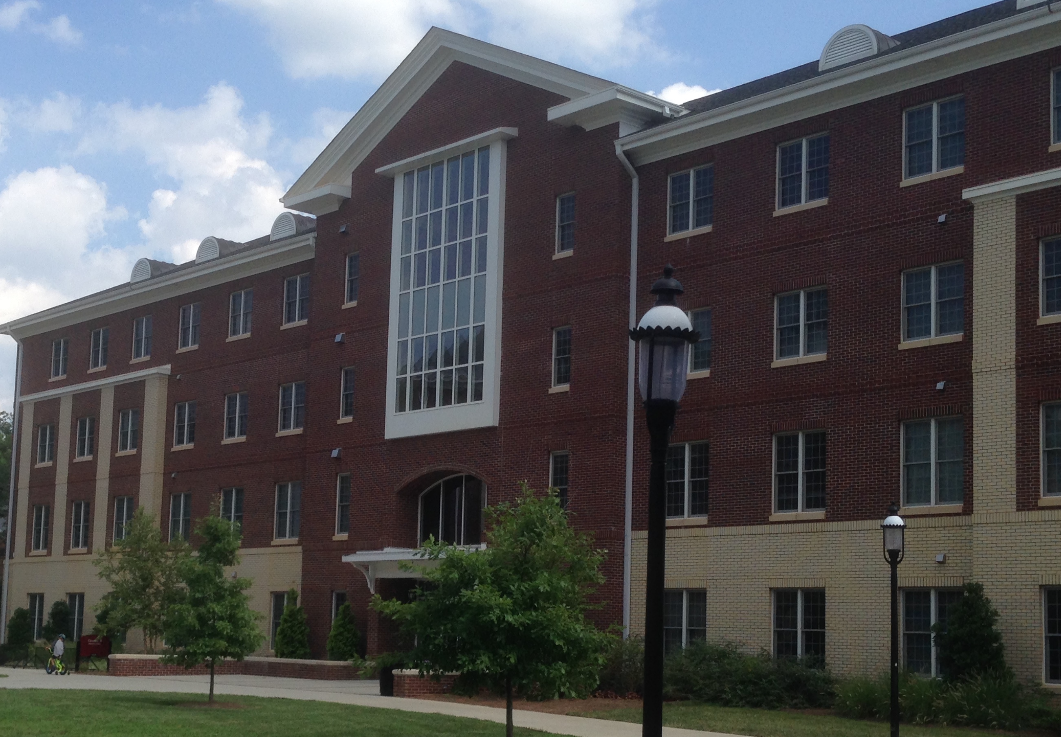
Activities
We will be building a list of activities that we’ll develop this year. Some activities emphasize community-building. Others will help us understand international issues and trends. Many should help us develop social networks and build relationships. And some will be just plain fun. Take advantage of them. We will designate which of our activities are official for the ILLC, which means that your attendance is expected – not only for your development but also because in our multi-cultural environment your presence makes us all richer. As Elon President Leo Lambert has often said during First-Year Convocation, “If you are invited to a great banquet, don’t make yourself a bologna sandwich.” Seize the day: Enjoy, explore, learn, share, interact, venture . . . . You will not regret it.
You will have my support as your faculty advisor in residence, along with support of our Global Neighborhood’s Faculty Director (Dr. Jennifer Eidum Zinchuk), your Community Director (Kaila Price) and your Resident Assistant (Annaliese Jaffe). Other key people are our Global Graduate Assistant (Sam Beckas) and our program assistant (Sarah Kehl) in our neighborhood office. We will work closely with you to create meaningful experiences. I am here for you and will be attending selected activities with you to guide discussions and reflections and to answer questions along the way.
We’ll work on developing more to come. But at the start of the school year, it’s enough to get to meet one another and commit ourselves to many kinds of learning and enjoyment.
Traditions
We’re still very much in the process of creating traditions. Perhaps the strongest is the habit of showing interest and taking pride in one another. If the ILLC is known for anything, it’s probably the close networking among members-residents. Students in this group carry out a lot of activities together, from dining at nearby Lakeside to studying together in the lounge to competing on teams, such as the women’s rugby club. Because our students are known for their deep focus in academics, this learning community also has a reputation for its interest in meeting with speakers and academics to explore ideas a little more deeply. Finally, the group takes pride in being among the top LLCs in competing and winning competitions, whether in producing the finest video or racking up the most points in the campus-wide Challenge Cup. This is a group that uses its broad skills and interests to work together.




