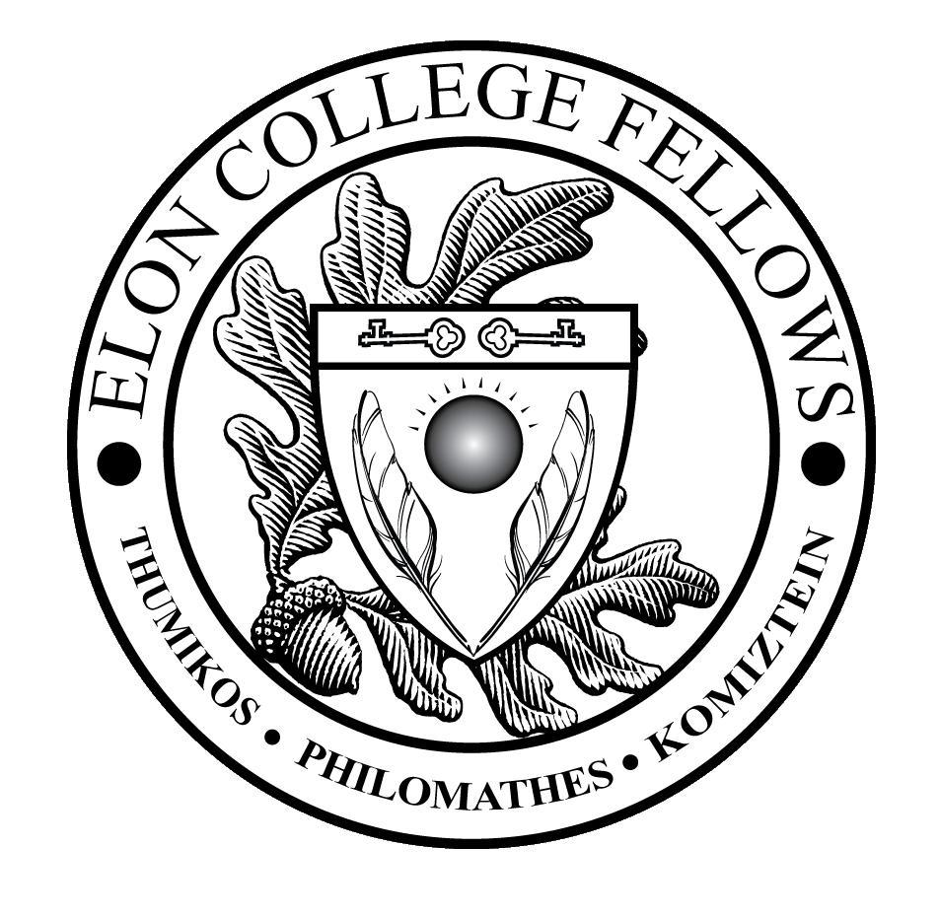
The Elon College Fellows Living-Learning Community (ECF LLC) Syllabus for the 2019-2020 Academic Year
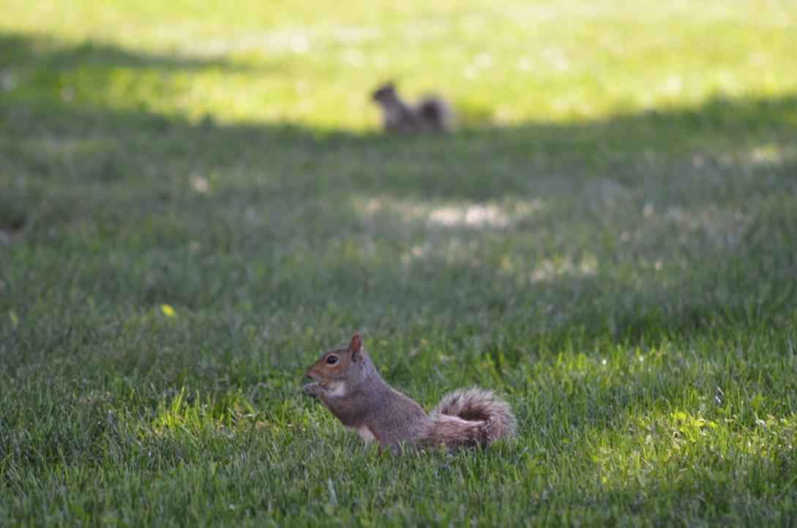
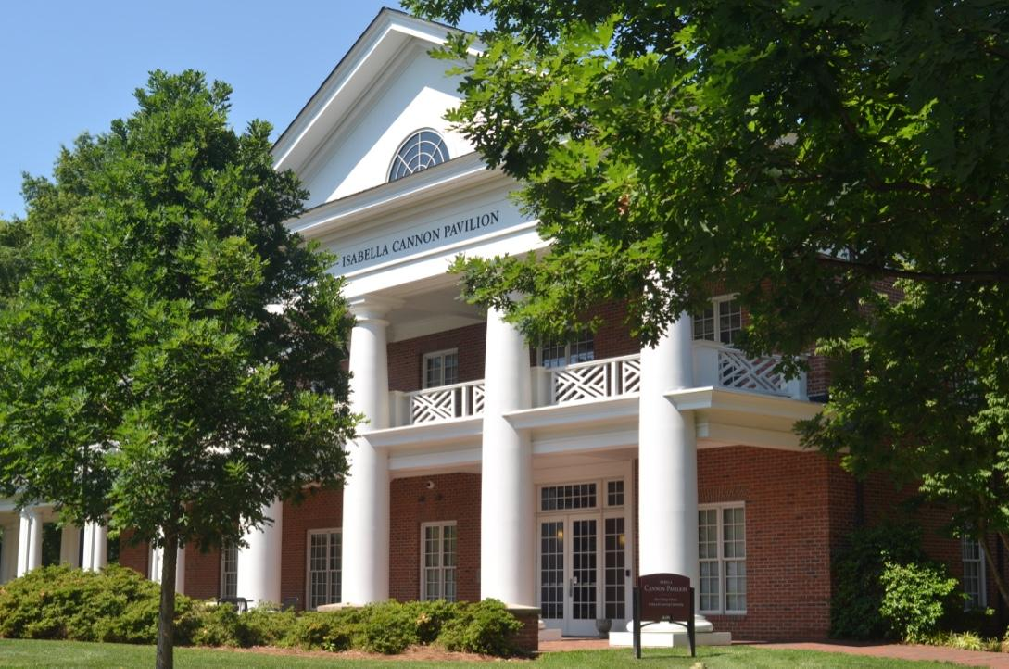
Your New Home! Some of the Neighbors!

Faculty Advisors:
Dr. Victoria Moore (vmoore3@elon.edu)
Dr. Pamela Winfield (pwinfield@elon.edu)

Offices: McMi 311

Other East Neighborhood folks to know:
Community Director: Sylvia Wade (swade6@elon.edu)
Faculty Director: Mark Dalhouse (mdalhouse@elon.edu)
Program Assistant: Amy Vaughn (avaughn4@elon.edu)

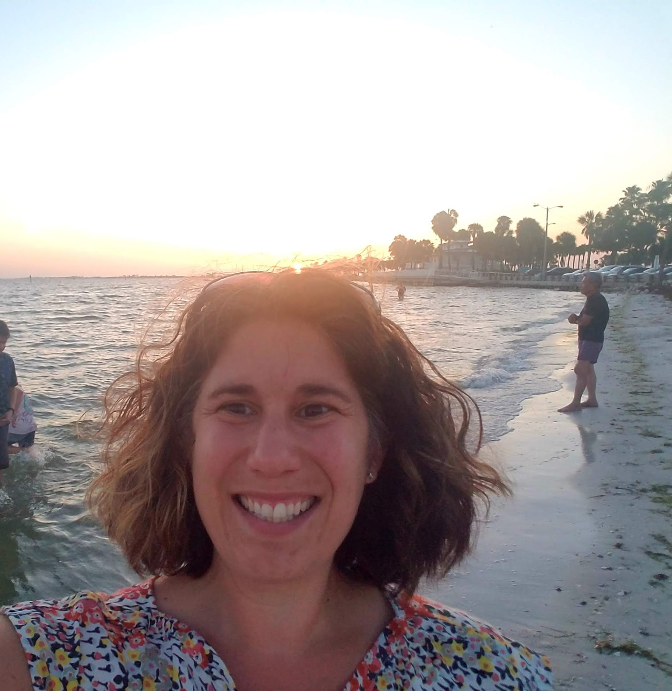
Victoria Moore (LLC Advisor): Hello! I’m really looking forward to working with you this year. I am an Assistant Professor of Chemistry, located in McMichael building just across the road from the Academic Village. I teach biochemistry & chemistry courses as well as run a cancer research lab. I am originally from New Jersey and went to James Madison University for undergrad. I kept traveling further south to Wake Forest University where I earned my Ph.D. in Molecular Medicine. Afterwards, I moved to Boston for my post-doc research training at Harvard Medical School and then returned to NC and become faculty at Elon in 2010. I am married and have two girls who keep me busy when I’m not on campus. (she/her/hers LGBTQIA Ally)

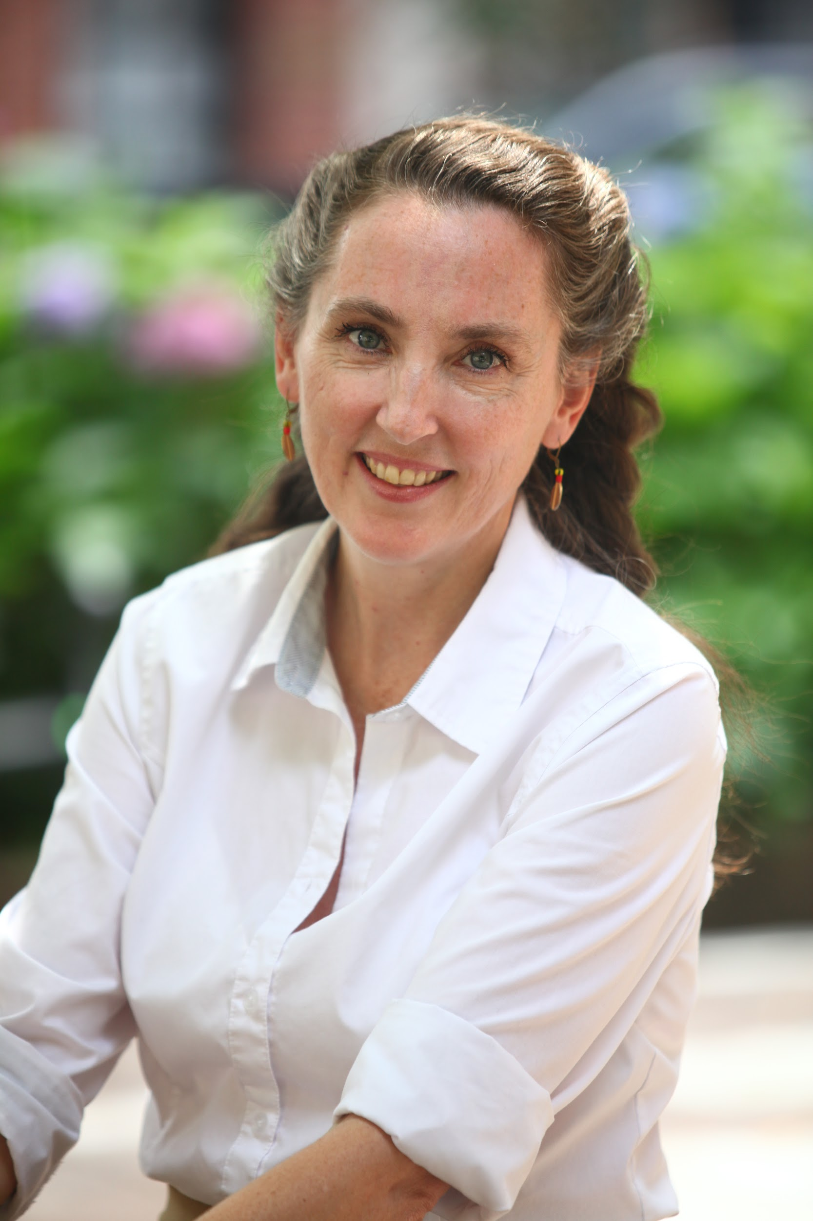
Pamela D. Winfield (LLC Advisor) Hi folks – welcome to the ECF LLC! I am an Associate Professor in the Department of Religious Studies across the quad. I teach courses on East Asian religions and visual / material culture - especially Japanese Buddhist art and doctrine - but I love it all. I grew up in the Village (NYC), and when I wasn’t studying abroad in Italy or France, I spent most of my undergraduate career at Georgetown in the black box theater. I backpacked home solo for 6 months after teaching English in Japan, did the corporate America thing, got my PhD from Temple University, and hit the jackpot when I joined the faculty here at Elon in 2008. I still love to travel but I am always happy to come back home to NC where we are raising our three boys about 5 minutes from campus. (she/her/hers; LGBTQIA ally)
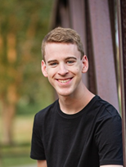
Pierce Johnson (Resident Assistant) - I'm Pierce and I'm a sophomore this year. I’m currently pursuing a double major in Psychology and Philosophy, as well as minors in Statistics and Classical Studies. I’m originally from Parker, CO and I'm a triplet! On campus, I'm heavily involved in the marching band, philosophy club, psychology club, and I try to make it to the club tennis practices throughout the week when I find the time. I hope you're all having an awesome summer, and I can’t wait to meet everyone in August!!

Welcome to the ECF LLC!
Welcome to the Elon College Fellows LLC! This living-learning community brings together Elon College Fellows to share intellectual and social pursuits in Elon’s East Neighborhood. You were carefully selected to be part of this LLC, so please treat it as an honor and as an opportunity to learn about Elon University and the rest of the world through your interactions and engagement with fellow residents, cultural events, speakers, concerts, and other activities, both within East Neighborhood and beyond.
This unique community fosters cross-cultural appreciation, intercultural competency, respect for diversity, and curiosity and awareness about international trends and issues. It is a multicultural environment that values difference and shares Elon University’s priority of internationalizing the campus through activities such as study abroad, international exchanges, and language learning.

Goals:
- To create a community that serves as a social network and intellectual resource to help students succeed inside and outside of the classroom
- To take advantage of the activities happening across campus and connect those activities with international themes and trends, encouraging discussion and reflection
- To bring together Elon College Fellows with common challenges to share solutions in a collaborative environment
- To connect students to a faculty director, to faculty advisors, and to a resident assistant (RA) who also shares these interests and who will work to build relationships around these areas of mutual concern
- To learn from differences and diversity among the residents
- To integrate classroom themes with residential conversations and planned programming in an intentional, learning-centered community

Activities:
You will find a timeline below of a few activities we’ll participate in this year. These activities are intended to build community and understand important issues, have fun and take advantage of them! In the timeline, you will see that these activities are required for the ECF LLC, which means that your attendance is expected. As former Elon President Leo Lambert has said many times at Convocation, “If you are invited to a great banquet, don’t make yourself a bologna sandwich.” Seize the day: enjoy, explore, learn, share, interact, venture… You will not regret it.
You will have the support of your Faculty Advisors (Pamela Winfield and Karl Sienerth), and your neighborhood staff: Community Director (Sylvia Wade),
Faculty Director (Mark Dalhouse) and the Program Assistant (Amy Vaughn) and Resident Assistant (Pierce Johnson), who will work with you to make the most out of this experience. We are here for you and will be attending selected activities with you, to guide discussions and reflections and to answer questions along the way.
Not only will you get to know your fellow ECF LLC students, but you will also be invited to participate with them in some University-wide LLC activities, including a mural/banner competition, the video challenge, and various service opportunities. Some required events are found in the following list of activities.
ECF LLC and EAST Neighborhood Activities for 2019-20

August 23 – Move In Day (8:00 am)
August 24 – East Extravaganza (10:00 pm, East Intersection)
August 28 – Neighborhood BBQ (TBD, East Intersection)
September 2019 – We want to have lunch with each of you in small groups (2-3 people). This
is a casual meal intended for us to get to know one another.
September 3 – Fall ECF Picnic (5:00-8:00, Mckinnon Hall 128)
September 5 – Neighborhood Dinner (5:30 pm, Lakeside 212)
September 6 – Tour of Burlington (4:00 pm, meet in East Parking Lot)
September 7 – Rise Against Hunger (9:00 am-1:00 pm, Mckinnon Hall)
September 11 – 9/11 Day of Service with Kernodle Center (TBD)
September 11 – United 93 Showing (7:00 pm, LaRose Theatre)
September 13 – Get on the Bus (Kernodle Center)
September 18-19 – Common Reading Lecture (TBD, Alumni Gym)
September 24 – Big Cat Colloquium (4:00-7:30)
September 27-28 – Elon University Family Weekend
October 7 – East Feast (6:30 pm, TBD)
October 17-20 – Fall Break
October 31 – East Trick-Or-Treats (7:00 pm, East Neighborhood)
November 1-2 – Homecoming Weekend
November 12 – Soup & Society (6:30 pm, East A 3rd Floor)
November 19 – fEASTgiving - SNA Event (7:00 pm, East B 2nd Floor)
November 22-December 1– Thanksgiving Break
December 8 – Gingerbread House Building (1:00 pm, East)
December 9 – Fuel for Finals (7:00 pm, East B 1st Floor)
December 14-January 2 – Winter Break
January 21 – MLK Soup and Society with the CREDE (6:30 pm, McBride Gathering Space)
February 4 – Black History Month Dinner with Oaks and the CREDE (6:00 pm McKinnon
Hall)
February 11 – Soup and Society (6:30 pm, East B 3rd Floor)
February 21 – International Civil Rights Museum Trip (2:00 pm, meet in East Parking Lot)
March 3 – Soup and Society (6:30 pm, East C 3rd Floor)
March 6 – Fellows Weekend Reception (7:00-9:00, McKinnon Hall)?
March 7 – Service Saturday (TBD, meet in East Parking Lot)
March 14-22 – Spring Break
March 28 – Live Under the Oaks (2:00 pm, West Hall)
April 18 – Service Saturday (TBD, meet in East Parking Lot)
April 23 – Ice Cream Social (5:00-7:00, Lindner Front Patio)
April 28 – SURF Day
May 12 – SNA Send-Off Event (6:00 pm, The Intersection)

(Bold: Campus-wide Events, Italicised: ECF Events, Other: East Neighborhood Events)
In addition, these speakers will be coming to campus next year, and many more TBA!
https://www.elon.edu/E-Net/Article/173899

